Name: Shriya Ramya Mohan Exp No: 4
Roll no: 241901106 Date : 1/9/2025

IMPLEMENT PACKET SNIFFING USING RAW SOCKETS IN PYTHON

AIM:
To implement a packet sniffer using raw sockets in Python that captures network frames.

INTRODUCTION
Packet sniffing is the technique of capturing and analyzing packets traversing a network interface. Raw sockets allow user programs to receive and send packets including link-layer headers This experiment demonstrates how to create a raw socket, capture frames, and parse common protocol headers to inspect packet metadata.

ALGORITHM
1. Get local IP address.
2. Create a raw IPv4 socket and bind it to that IP.
3. Enable IP header inclusion and turn on promiscuous mode (so the socket sees all packets).
4. Loop forever:
- Read a packet from the socket.
- Take the first 14 bytes as the Ethernet header and the rest as payload.
- Extract destination MAC, source MAC, and protocol from the header.
- Print the MACs and protocol.
5. Repeat until you stop the program (Ctrl+C).

import socket
import struct
import binascii
import textwrap

def main():
# Get host
host = socket.gethostbyname(socket.gethostname())
print('IP: {}'.format(host))

# Create a raw socket and bind it
conn = socket.socket(socket.AF_INET, socket.SOCK_RAW, socket.IPPROTO_IP)
conn.bind((host, 0))

# Include IP headers
conn.setsockopt(socket.IPPROTO_IP, socket.IP_HDRINCL, 1)
# Enable promiscuous mode
conn.ioctl(socket.SIO_RCVALL, socket.RCVALL_ON)

while True:
raw_data, addr = conn.recvfrom(65536)
dest_mac, src_mac, eth_proto, data = ethernet_frame(raw_data)

print('\nEthernet Frame:')
print("Destination MAC: {}".format(dest_mac))
print("Source MAC: {}".format(src_mac))
print("Protocol: {}".format(eth_proto))

# Unpack ethernet frame
def ethernet_frame(data):
dest_mac, src_mac, proto = struct.unpack('!6s6s2s', data[:14])
return get_mac_addr(dest_mac), get_mac_addr(src_mac), get_protocol(proto), data[14:]

# Return formatted MAC address AA:BB:CC:DD:EE:FF
def get_mac_addr(bytes_addr):
bytes_str = map('{:02x}'.format, bytes_addr)
mac_address = ':'.join(bytes_str).upper()
return mac_address

# Return formatted protocol ABCD
def get_protocol(bytes_proto):
bytes_str = map('{:02x}'.format, bytes_proto)
protocol = ''.join(bytes_str).upper()
return protocol
main()

CODE
*l.
OUTPUT:
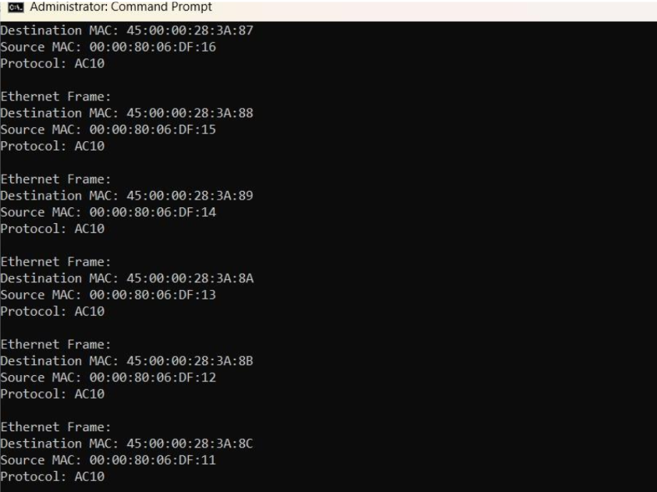

RESULT:
The program successfully captures network packets and display their MAC address and protocol details.

